Current Roasts
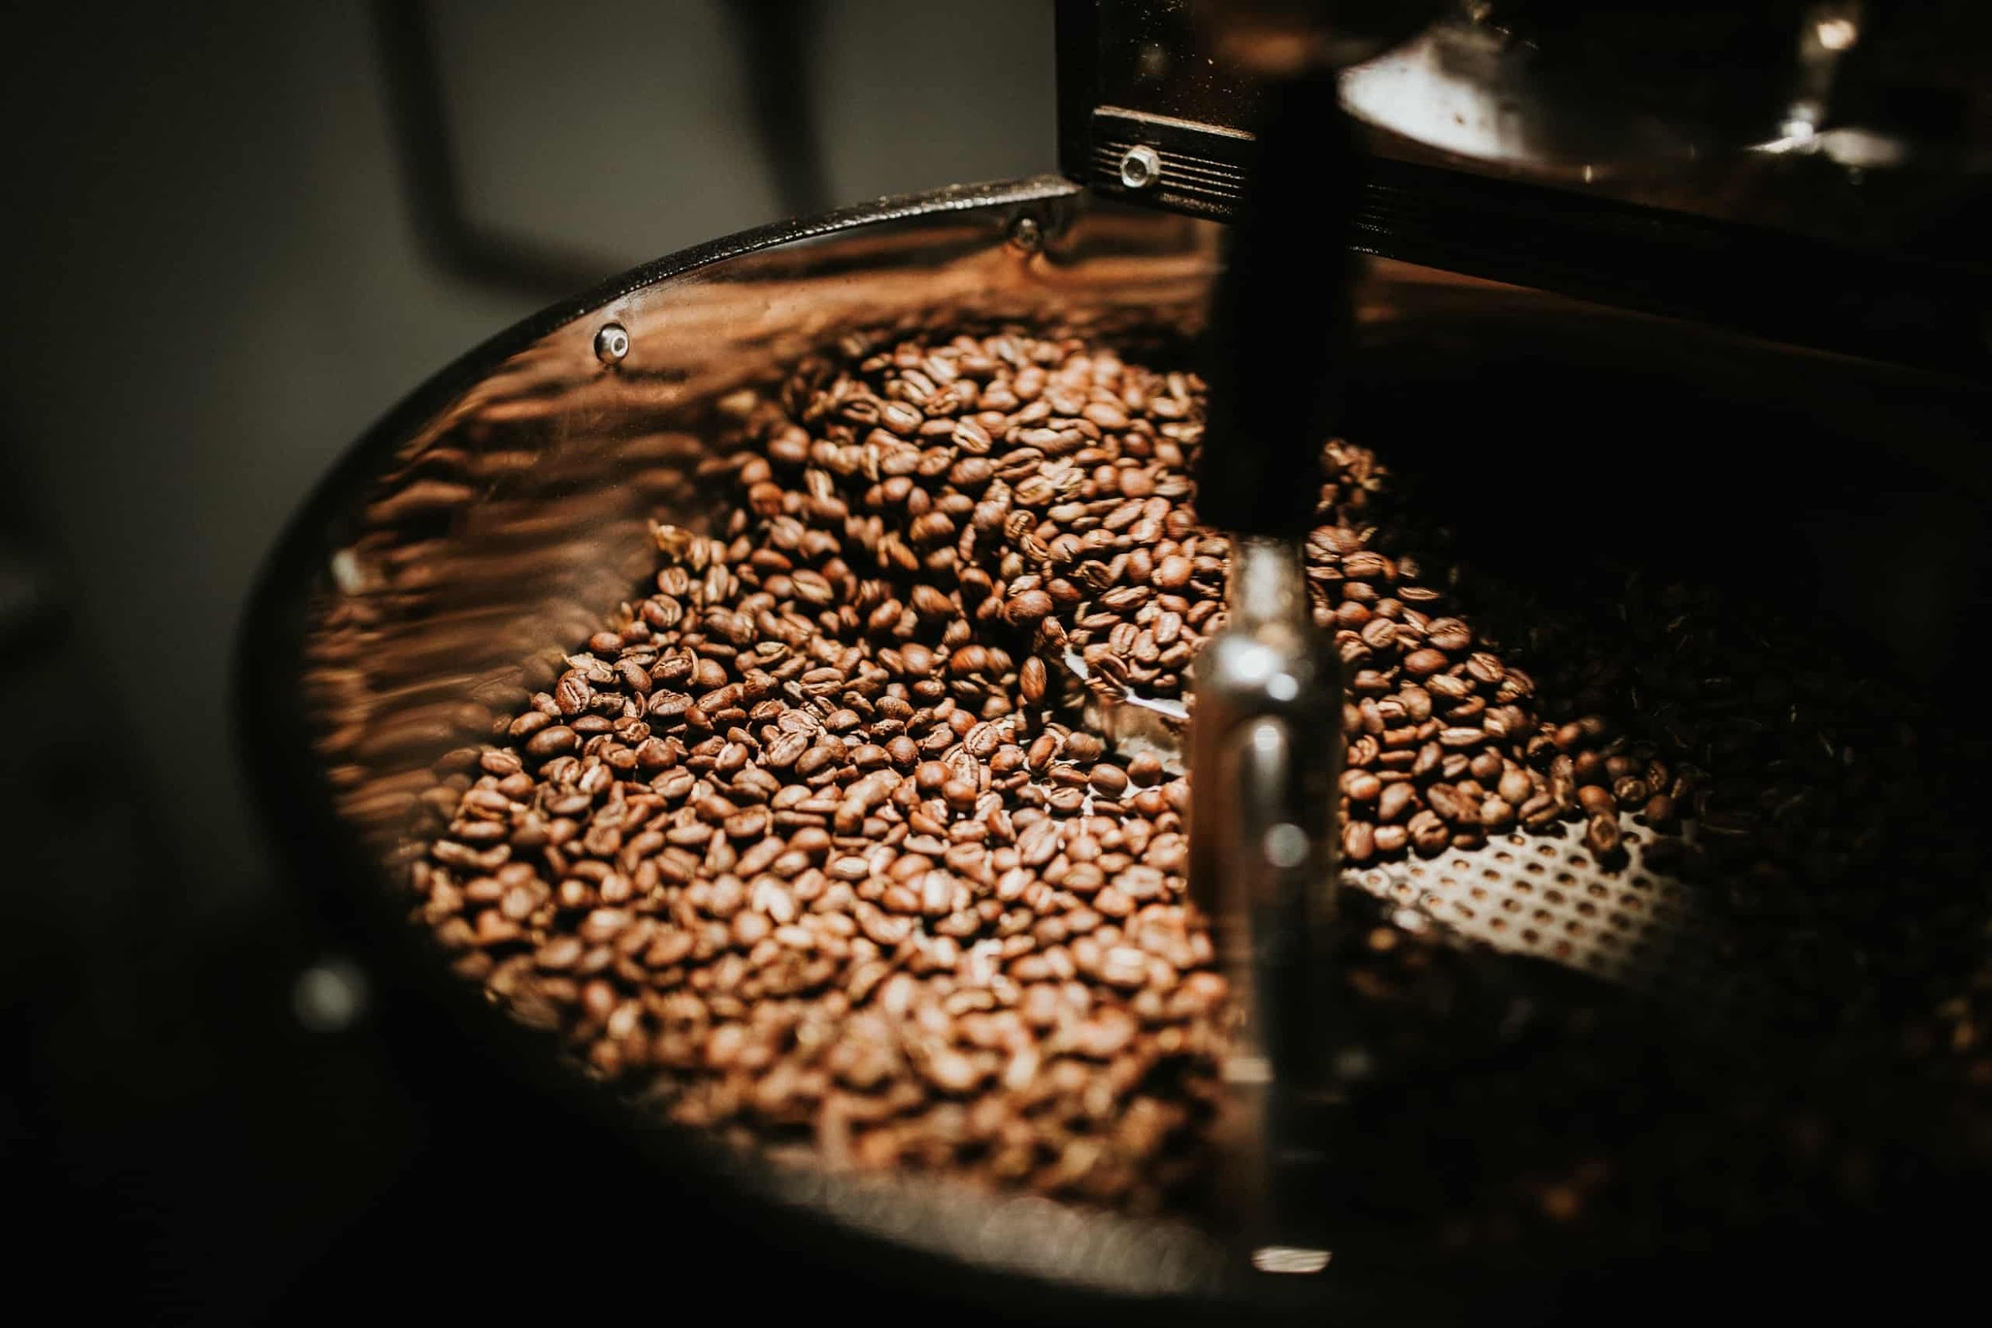At Roasters, each bean is roasted in-house to its own profile in order to achieve maximum flavor and aroma.
In general, you can expect a coffee from Central or South America to have a smokier taste with hints of chocolate, caramel, malt, or sometimes a citrus touch. Coffees from Africa tend to taste a bit fruitier or winey. They are brighter in feel on the tongue. Indonesian coffees lean toward spicier tastes with more floral tones. They have a bit more exotic flavors.
The majority of our beans are Fair Trade Organic. By purchasing these beans, we are engaging in a socially responsible economic practice.

Our Beans
Roasters sells both ground and whole beans for you to take home and enjoy at your convenience. Beans are available in 1/4 lb, 1/2 lb, and 1 lb bags. You can order in store or online – we will even ship our beans to you! Own a business? Contact us for wholesale prices.
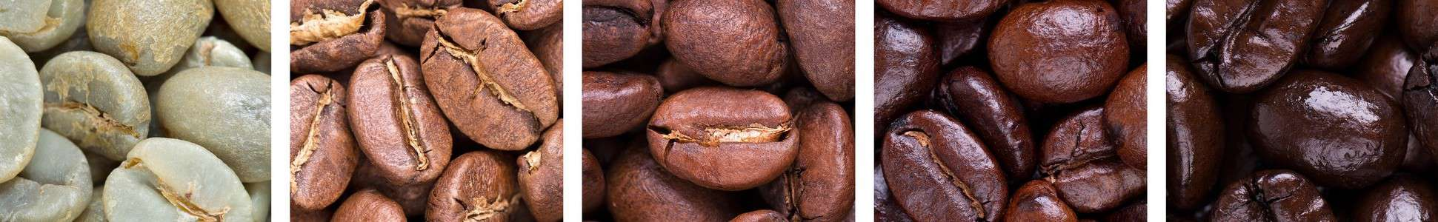

Our Blends
Barista Blend (Tanzania, Colombia)
Rich, full bodied with a touch of fruitiness.
Breakfast Blend (Guatemala, Yirgacheffe, Colombia)
Medium bodied, balanced and full flavored.
Dave’s Blend (Brazil, Costa Rica, Papua New Guinea)
Dark roasted, full bodied, rich and complex.
Dark Duo (Peru, Tanzania)
Dark, full bodied, rich with a zing.
Evening Blend (Sumatra, Colombia)
Smooth, full bodied, and rich.
Fiesta Blend (Guatemala, Costa Rica, Colombia)
Rich, smooth and full bodied.
Hit the Road Jack (Costa Rica, Ethiopian Sidamo, Colombia)
Dark, full bodied, bright.
House Blend (Colombia, Costa Rica, Tanzania)
Dark, full bodied.
Home Sweet Home (Yirgacheffe, Colombia)
Medium body, slightly sweet, winey.
Smokestack Blend (Brazil, Nicaragua)
Dark roasted, heavy body, hint of smokiness.

Flavored Beans
Our medium roasted Mexican beans lightly coated with flavoring
Flavors: Caramel Pecan, Cinnamon, Coconut, Hawaiian Hazelnut, Hazelnut, Highland Creme, Jamaican Me Crazy, Nutty Delight, Southern Pecan, Toasted Maple Nut, Vanilla Nut, White Chocolate Raspberry, and Yule Log

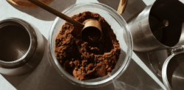

Single Origins D – Available as Decaf, L – Available as Light

Latin America
Brazil – D, L
Bold but not overly dark. The chocolate/caramel comes through for a richly, satisfying cup of coffee.
Colombia – D
A classic medium roast with medium body and acidity. This coffee is smooth with a hint of caramel sweetness.
Costa Rica – Hacienda La Minita Premium Bean
This coffee is a direct buy from the estate Hacienda La Minita in Costa Rica. “Our coffee has brilliant acidity, full body and sweet flavors of orange, maple and fine chocolate.” Smooth and clean with a satisfying finish.
Costa Rica – D
Medium to dark roasted, full-bodied and rich. Hints of bittersweet dark chocolate and caramel.
El Triunfo – D
A rich bean from the Chiapos region of Mexico. A dark, mellow coffee with a smooth finish.
Guatemala – D
Medium light roast with a light body, pleasant flavor and a delicate smoky tone.
Mexico – D
Medium light roasted with medium body and light pleasant flavor with hints of citrus.
Peru – L
Dark roasted, heavy bodied and smoky. A classic French Roast without the bitterness of a “traditional” French Roast. Light version is a bit sweeter, a bit nuttier, without the smoke and intense body.

Africa
Ethiopian Sidamo
Light, bright, pleasantly sweet with a touch of fruitiness.
Ethiopian Yirgacheffe
Medium roast with a bright, fruity taste.
Tanzanian Peaberry
Dark roasted with a lighter body and clean pleasant flavor. A rich cup.
Kenya AA
The most aromatic and brightly acidic coffees in the world come from Kenya. Roasted slightly darker than our Yirgacheffe to balance the intense acidity, this fruity bean has delicious citrus and berry notes and fascinating complexity. Our head roasters’ favorite!

India and Indonesia
Harimau
Dark roasted from Sumatra. Rich, mellow, hints of fruit, full bodied, and exotic spices.
Indian Monsooned Malabar
Medium roast. Smooth and mellow with undertones of baker’s chocolate.
Papua New Guinea
Medium to dark roast. Heavier bodied and spicy with a floral aroma.
Sumatra
Medium roast. Medium body with a bright, pleasant, and mellow flavor.

